EC-341 Digital System Design
BS(CE)-2021
LAB REPORT # 3

Submitted By:
Reg. No. | Name
21-CE-009 | Huzaifa Shahbaz

Department of Computer Engineering
BS Computer Engineering Program
HITEC University Taxila
 | Presentation  (Format(0.5)+ Title (0.5)+  Conclusion(1)  +Procedure(2)  +Objective(1)) | Calculation/ Coding | Observation/  Program Results | Total
Total | 5 | 5 | 5 | 15
Obtained

___________________________
Lab Instructor.
Engr. Fasih Ahmad

Experiment #3
Overview of ZYBO
Objective:
1. Overview of ZYBO.
2.Zynq AP SoC Architecture.
3.What is Constraints File?
4. Lab Tasks.

Software Used:
Xilinx Vivado

Procedure:
The ZYBO (ZYnq BOard) is a feature-rich, ready-to-use, entry-level embedded software and digital circuit development platform built around the smallest member of the Xilinx Zynq7000 family, the Z-7010. The Z-7010 is based on the Xilinx All Programmable System-onChip (AP SoC) architecture, which tightly integrates a dual-core ARM Cortex-A9 processor with Xilinx 7-series Field Programmable Gate Array (FPGA) logic. When coupled with the rich set of multimedia and connectivity peripherals available on the ZYBO, the Zynq Z-7010 can host a whole system design. The on-board memories, video and audio I/O, dual-role USB, Ethernet, and SD slot will have your design up-and-ready with no additional hardware needed. Additionally, six Pmod connectors are available to put any design on an easy growth path. The Zynq 7010 AP SoC offers the following features: 1.650Mhz dual-core Cortex-A9 processor
2.DDR3 memory controller with 8 DMA channels
3.High-bandwidth peripheral controllers: 1G Ethernet, USB 2.0, SDIO
4.Low-bandwidth peripheral controller: SPI, UART, CAN, I2C
5.Reprogrammable logic equivalent to Artix-7 FPGA
i.4,400 logic slices, each with four 6-input LUTs and 8 flip-flops ii.240 KB of fast block RAM
iii.Two clock management tiles, each with a phase-locked loop (PLL) and mixed-mode clock
manager (MMCM) iv.80 DSP slices
v.Internal clock speeds exceeding 450MHz
vi.On-chip analog-to-digital converter (XADC)

Tasks
Task 1:
Write a program which toggles LED using a slide switch.
CODE:
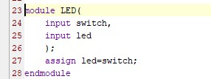
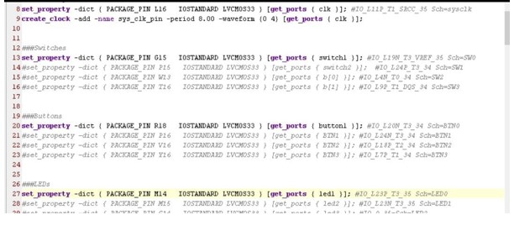 Output:
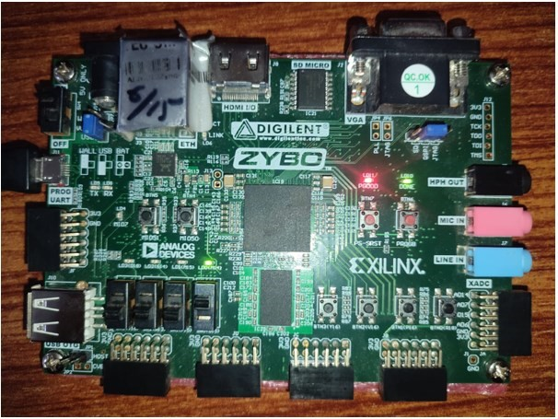

Conclusion:
In this lab we had design the zybo,by using its hardware connect into the Xilinx Vivado and also we check the working Zybo.

